GREEN PAPER
on the insurance of natural and man-made disasters

1. Introduction
As many other regions of the world, the European Union is vulnerable to nearly all types of natural disasters. Disasters not only cause human losses but also damages to the value of billions of euros every year, affecting economic stability and growth. Disasters may have cross-border effects and can potentially threaten entire areas in neighbouring countries. Even where costs of major disasters are locally concentrated, if costs are inadequately covered by insurance then individual Member States may carry large fiscal burdens, which could cause internal and external imbalances. This is thus an important issue for citizens, companies and governments across the Union.
In 2010 the Council invited the Commission to evaluate and report on the potential for the European Union to facilitate and support increased coverage of appropriate disaster risk insurance and financial risk transfer markets, as well as regional insurance pooling, in terms of knowledge transfer, cooperation, or seed financing. Subsequently, the Commission organised a Conference on prevention and insurance of natural catastrophes and conducted a study entitled "Natural Catastrophes: Risk Relevance and Insurance Coverage in the European Union".
This Green Paper poses a number of questions concerning the adequacy and availability of appropriate disaster insurance and accompanies the Communication entitled "An EU strategy on adaptation to climate change". The objective is to raise awareness and to assess whether or not action at EU level could be appropriate or warranted to improve the market for disaster insurance in the European Union. More generally, this process will also expand the knowledge base, help to promote insurance as a tool of disaster management and thus contribute to a shift towards a general culture of disaster risk prevention and mitigation, and bring in further data and information.
The following graphs provide an overview of the occurrence of natural and man-made disasters in the European Union during recent years.
Graph 1: Natural disasters in EEA States (1980–2011)
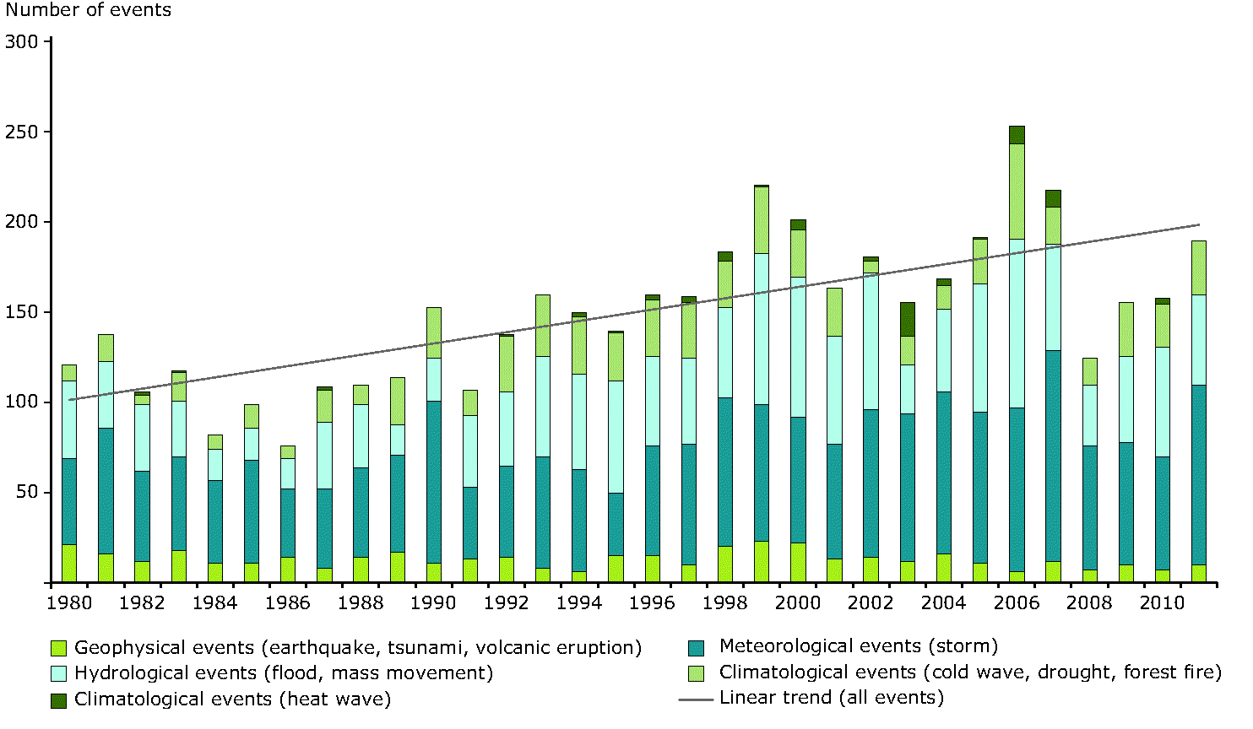
Source: European Environment Agency, Climate change, impacts and vulnerability in Europe 2012, An indicator-based report, EEA Report No 12/2012.
Storm surges, river or flash floods are one of the main natural disaster risks facing Europe (e.g., the 2012 United Kingdom, Ireland and Romanian floods, 2002, 2005 and 2010 Europe-wide floods).
Graph 2: Floods – maximum historical losses
Source: Joint Research Centre, European Commission (2012), Natural Catastrophes: Risk relevance and Insurance Coverage in the EU, based on available data.
Wild forest fires are also a threat that Member States have to deal with every year. The 2003 heat wave was the hottest on record in Europe since at least 1500.
A number of winter and wind storms have also caused severe damage in European countries in recent years.
Graph 3: Storms – maximum historical losses
Source: Joint Research Centre, European Commission (2012), Natural Catastrophes: Risk relevance and Insurance Coverage in the EU, based on available data.
The 2009 L‘Aquila and the 2012 Emilia Romagna earthquakes resulted in deaths, injuries and devastation of residential and commercial property. Earthquakes can also trigger tsunamis in Europe (such as in 1908 in Messina or in 1755 in Lisbon).
Graph 4: Earthquake – maximum historical losses
Source: Joint Research Centre, European Commission (2012), Natural Catastrophes: Risk relevance and Insurance Coverage in the EU, based on available data.
The volcanic eruption of Eyjafjallajökull in March 2010 demonstrated how far-reaching the consequences of a natural disaster can be. Experience has shown that such an improbable event may have long-lasting and serious consequences for other parts of Europe and of the world.
Between 1980 and 2011, the economic toll of natural disasters in the whole of Europe approached 445 billion euro in 2011 values. About half of all losses can be attributed to a few large events, such as storms like Lothar in 1999, Kyrill in 2007 and Xynthia in 2010, and to the floods in central Europe in 2002 and in the United Kingdom in 2007. Damage costs from extreme weather events in EEA States have increased from EUR 9 billion in the 1980s to more than 13 billion euro in the 2000s (values adjusted to 2011 inflation).
Graph 5: Natural disasters in EEA States – loss events, fatalities and losses (1980 to 2011)
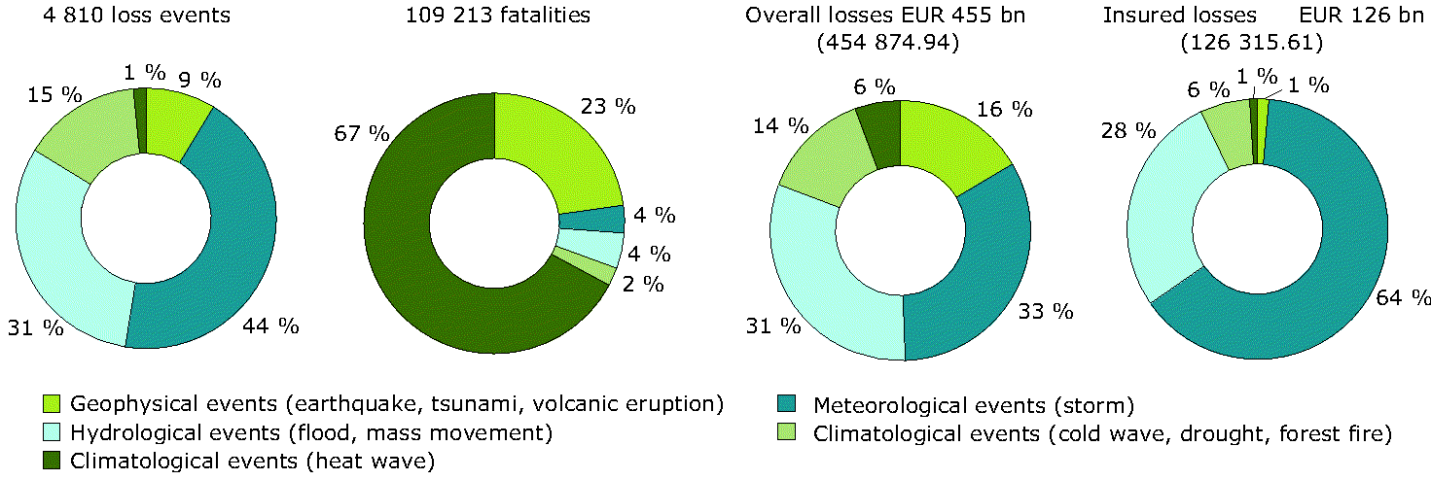
Source: European Environment Agency, Climate change, impacts and vulnerability in Europe 2012, An indicator-based report, EEA Report No 12/2012.
With climate change, insurance will be called upon to cover increasingly frequent and intense events. Changes in climate, demographics and population concentrations, growth in catastrophe-exposed areas and rising wealth and property values are increasing the exposure and vulnerability of economic assets and the severity of losses. In the short term, the effect of climate change on insurance may not be that significant. However, in the longer term, particularly in sectors or areas where insurance has not been customary, climate change could have an impact on the availability and affordability of insurance. Potential losses are highly dependent on changes in exposure and vulnerability. Overall, the probability of most types of extreme weather events is expected to grow significantly. As a result of increasing risks, insurance might become unavailable or unaffordable in certain areas. Unavailable insurance, one of the factors that contributes to vulnerability, may exacerbate the susceptibility of society, leaving governments with potentially large financial exposures.
Man-made disasters, such as industrial accidents involving dangerous substances can also have large-scale and cross-border impacts (i.e., the 2010 Gulf of Mexico accident related to offshore oil extraction, the 2011 alumina depot leaks in Ajka, Hungary). Furthermore, natural hazards and disasters, for example, lightning, low temperature or earthquakes, may trigger man-made (‘natech’ - Natural Hazard Triggering Technological Disasters) disasters such as atmospheric releases, liquid spills or fires (i.e., the 2011 Fukushima nuclear disaster, Japan). Such compound ‘natech’ disasters can occur more often due to the increased frequency of extreme natural events and the increased complexity and interdependency of industrial systems.
Graph 6: Industrial accidents in EEA States reported in the Major Accident Reporting System
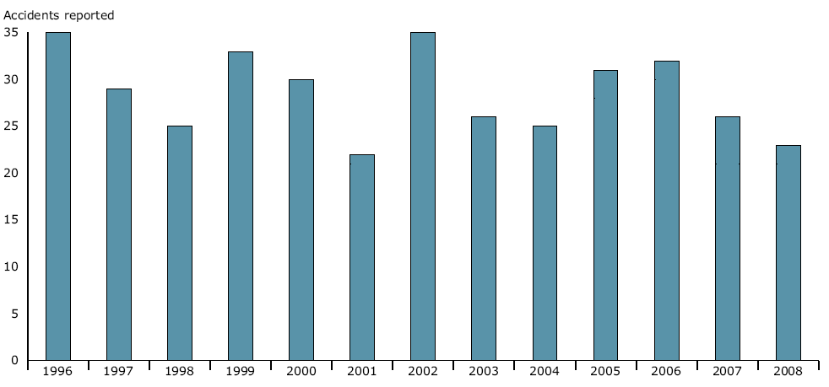Source: European Environment Agency, Mapping the impacts of natural hazards and technological accidents in Europe, EEA Technical Report No 13/2010.
Private insurance can address a number of related policy concerns and can contribute to sustainable public finances. Insurance is one of the tools for disaster risk management, together with risk prevention, preparedness and response measures: a functioning disaster risk insurance system, beyond risk sharing, can be operational at all levels of the risk management cycle, from risk identification and risk modelling to risk transfer and recovery. Insurance has a specific role: it does not prevent the loss of lives or assets but helps to reduce the economic impact and facilitates recovery after disasters. Well-designed insurance policies can also work as a market based instrument to discourage risky behaviour and promote risk awareness and mainstream disaster proofing in economic and financial decisions.

2. Market penetration of natural disaster insurance
Major natural disasters have large and significant negative effects on economic activity, both in their intermediate impact and in the longer term. It is mainly the uninsured losses that drive the subsequent macroeconomic cost, whereas sufficiently insured events are insignificant in terms of forgone output.
Recent analytical research undertaken by the Joint Research Centre shows that, based on available data, there is currently a low market penetration rate of disaster insurance in certain Member States. The analysis highlights that flood, storm and earthquake risk is, as expected, heterogeneous among Member States. However, based on available data, there are cases where disaster insurance markets do not seem to cope fully with existing risks. According to the research available, for storms, penetration rates are high in most Member States. However, for flood and earthquake, penetration rates are only high in cases where those risks are bundled with other risks.
Graph 7: Natural disasters in EEA States (1980 to 2011) – overall and insured losses
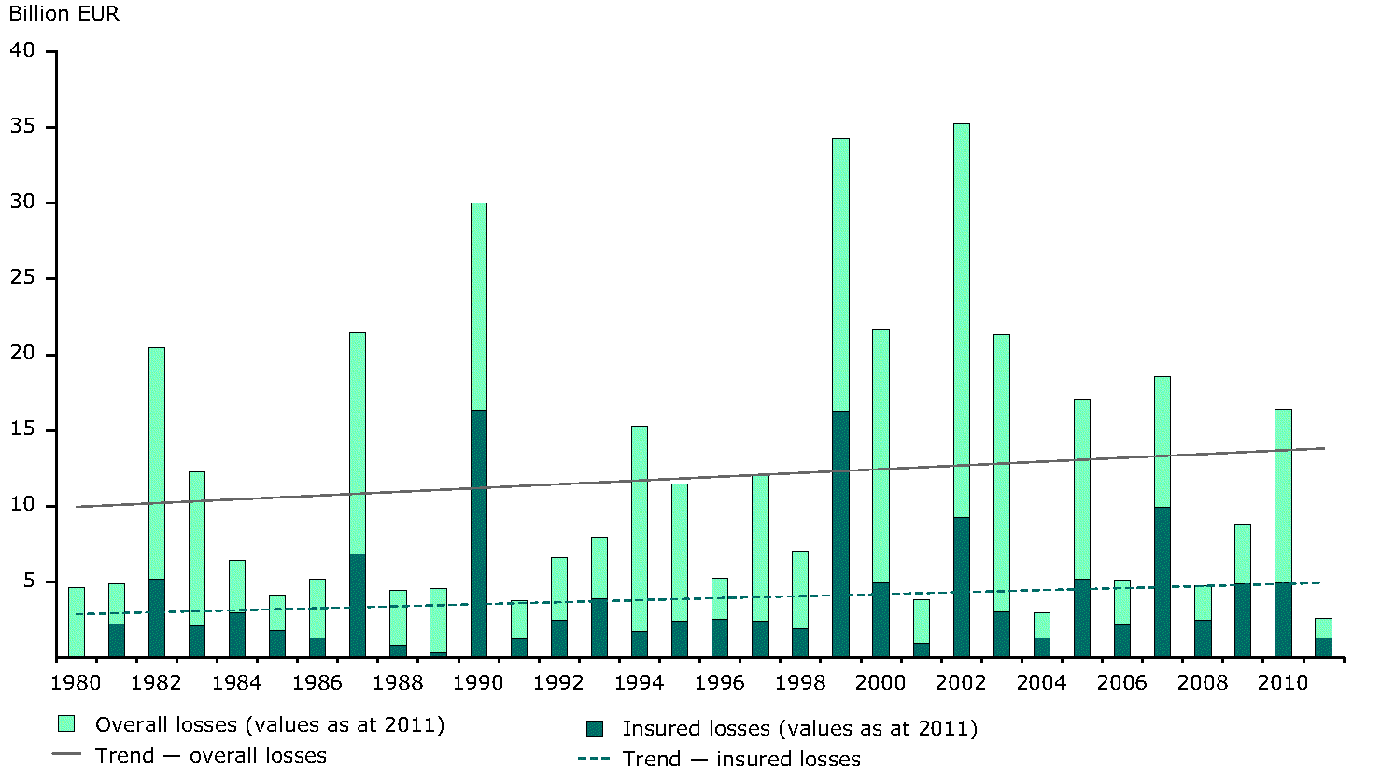
Source: European Environment Agency, Climate change, impacts and vulnerability in Europe 2012, An indicator-based report, EEA Report No 12/2012.
- Questions
- What is your view on the penetration rate of disaster insurance in the European Union? Please provide details and data to support your arguments. Is more research needed to understand any possible gaps in insurance supply and demand, insurance availability and coverage?

2.1. Product bundling
Insurance redistributes and reduces the financial risk associated with adverse events, by sharing costs either between individuals or over time. Insurance transfers individual risks to a pool, managed by an insurer. By aggregating or pooling risks, it is possible to reduce the cost of disasters in any particular time period.
The coverage provided by the private insurance market is funded through premiums, backed up by shareholder capital to meet likely deviations from the expected losses. Insurance premiums reflect the expected loss of the insured individual, an uncertainty margin for the given line of insurance business, a charge for the shareholder capital, a share of loading costs, i.e., administrative and other costs associated with underwriting insurance policies, and profit. The premiums are invested on financial markets, where the investment risks need to be uncorrelated with the underwriting risk, or re-insured to take some of the risk out of the pool. In this way, insurance spreads the risk of economic loss across society and over regions.
The specific feature of disasters is that they can damage many properties in a concentrated area at the same time: earthquakes occur along seismic fault lines, floods occur in low-lying areas and windstorms are very often directed at coastlines. This contrasts with other types of risk against which property insurance provides cover, such as theft or fire. It is unlikely, although not impossible, that an entire neighbourhood is burgled at the same time.
There are two main techniques to enable insurance to handle correlated risks. The first is to widen the pool, to make it very unlikely that individual risks are highly correlated through any potential disaster. Another common technique is bundling together several types of uncorrelated perils into a single insurance policy, e.g., fire and flood, storm or earthquake. Since each peril is independent from any other in the policy, bundling reduces the accumulated risks of any one hazard in the policy.
Product bundling represents general solidarity between consumers. Therefore, product bundling is sometimes introduced through a mandatory extension of simple risks such as fire or motor insurance to natural disasters coverage. Ideally, the system should recognise that some insured persons pose no or low risks compared to those from risk-prone areas, through, for instance, premium discounts.
Questions
- What further action could be envisaged in this area? Would mandatory product bundling be an appropriate way to increase insurance cover against disaster risks? Are there any less restrictive ways, other than mandatory product bundling, which could constitute an appropriate way to increase insurance coverage against disaster risks?

2.2. Compulsory disaster insurance
Consumers may not be inclined to insure themselves against risks that are unlikely to individually impact on them. People and businesses often underestimate the real risk of a disaster to them (risk myopia), and are not properly prepared to deal with the financial consequences. They rely on social networks or government relief.
Another issue may be that of adverse selection. This refers to the phenomenon in insurance whereby groups of people who feel that they are at a higher risk will purchase insurance to a large extent, whereas those who do not perceive such a high degree of risk will not feel it is necessary to purchase insurance. Adverse selection is particularly troublesome in disaster insurance. If only the highly exposed purchase insurance, the premium will be prohibitively expensive, and the pool will be too small to cope with disasters, since there is no buffer from unaffected members of the pool.
Compulsory disaster insurance could overcome those problems. It results in high market penetration and a large pool of insured persons. This facilitates risk spreading and reduces administrative costs per policy, while limiting ex-post government relief.
Questions
- Which compulsory disaster insurance, if any, exists in Member States? Are these insurance products generally combined with compulsory product bundling or obligation for insurers to provide cover? Is compulsory disaster insurance generally accompanied by a right for the customer to opt out of some disaster risks? What are the advantages/possible drawbacks? Would EU action in this area be useful?

2.3. Disaster insurance pools

Disaster insurance pools may extend the risk absorption capacity of the insurance market. They can provide coverage against aggregate exposures and risks that are uninsurable because of moral hazard, the small size of the given market or excessive claims cost. The pools may supplement systems with mandatory product bundling or with compulsory insurance.
The Commission renewed with modifications the co(re-)insurance pools exemption in the Insurance Block Exemption Regulation 267/2010. It recognised that risk sharing for certain types of risks, for which individual insurance companies are reluctant or unable to insure the entire risk alone, is crucial in order to ensure that all such risks can be covered.
The Regulation only allows co-operation through pools under certain conditions. Also, it is limited to agreements which do not afford the undertakings involved the possibility of eliminating competition in respect of a substantial part of the products in question. Pools outside the Regulation due to high market shares are not forbidden, but need to be self-assessed under competition rules as they may involve benefits so as to justify an exemption under Article 101(3) of the Treaty on the Functioning of the European Union.

2.4. Governments as (re-)insurers and (re-)insurers of last resort
Public authorities may be involved as insurers or may sponsor state-mandated catastrophe insurance pools. Such insurance programmes can alleviate political pressure to allocate substantial governmental resources in the aftermath of a natural disaster. But the framework needs to prevent the problem of moral hazard, e.g., policy-holders might be encouraged to behave in riskier ways once they know that they will be covered by public resources whether they protect themselves beforehand or not.
Through public-private partnerships, insurers may offer their expertise and tools (such as risk information platforms) to assess the risks, sell policies and in some cases advise governments in their investment decisions. Insurers may also be required to provide insurance coverage for medium-sized losses; the government limits its exposure and insurers bear a level of risk that is within their capacity.
Governments may also manage re-insurance programmes. They can require the private market to take on and pay for some proportion of the risk, i.e., quota-share treaties.
Governments may serve as (re-)insurers of last resort by taking on risks above a certain disaster damage level, i.e., stop-loss re-insurance. This approach blends the potential risk-spreading capacity of the government and the ability of the market to apply insurance principles and also to use its administrative capacity, i.e., collecting premiums, marketing and handling claims. Public programmes, therefore, may provide for cover at the highest risk levels, while the private market retains some or all of the lower tiers of risk.
Questions
- How can state or state-mandated disaster (re-)insurance programmes be designed and financed to prevent the problem of moral hazard?

2.5. Parametric index-based weather insurance and other innovative solutions

2.5.1. Parametric index-based weather insurance
Under traditional weather-related insurance schemes, such as property or liability insurance, insurance compensation will be paid out following an assessment of the insured party's losses. Once a loss assessment is completed and agreed, the insured party receives an indemnity pay-out.
Under a parametric index-based insurance scheme, losses resulting from extreme weather-related events are compensated when a pre-defined weather index deviates from the historic average, irrespective of the actual loss. That type of insurance relies on the measurement of an objective and independent index that is highly correlated with the actual loss. Traditional indemnity-based and parametric insurance can be combined.
Building on lessons and experience from different regional initiatives, parametric insurance could be considered as a solution both for the private and public sectors, e.g., for critical public infrastructure. It can improve affordability of insurance by reducing administrative costs, because it does not include a claims adjustment process. It also speeds up pay-outs, and can be associated with simpler insurance contracts. Parametric covers can help reduce information asymmetries between insurers and customers. On the other hand, such contracts present a significant basis risk, i.e., the claim pay-out does not match the actual loss incurred and policy-holders are not necessarily able to assess it.
Insurance is a critical requirement for development as uninsured losses can extend the cycle of poverty and impede economic growth. Alternative, simplified risk transfer tools such as micro-insurance products are being developed in developing countries. Parametric insurance programmes, supported by the Commission, have also been implemented in third countries, particularly exposed to weather and catastrophic risks such as droughts, earthquakes, and storms.

2.5.2. Meteorological research
The complexities of parametric design and basis risk may be significant constraints on extending these schemes. Meteorological research needs to identify viable indexes. It can only be scaled-up for widespread coverage if there is systematic coverage of the territory, with weather stations sufficiently close to insured persons and risk zones mapped. In addition to the physical presence of meteorological stations, there is a need to collect, maintain, share and archive data and to make them readily available in relation to insured events. The use of satellite data in combination with numerical analyses and forecasts has already resulted in a continuous increase in the skills required for making meteorological forecasts.
Similarly, opportunities related to satellite-based indices that use remote sensing tools can be explored. Many economic sectors are sensitive to climate conditions, hence to a changing climate. Therefore, the benefits of investing in weather infrastructure will extend beyond the development of index-based insurance products, notably to forestry and agricultural products. The Commission is currently conducting consultations aimed at the future implementation of a Climate Change Monitoring service as part of the European Earth monitoring programme (GMES).

2.5.3. Insurance-linked securities
Insurance-linked securities such as catastrophe bonds or other alternative risk transfer instruments can be seen as an effective way of increasing insurance capacity for highly improbable, low-frequency, high-severity natural catastrophe events.
For insurers, re-insurers and businesses, the bonds provide multi-year protection against natural catastrophes with minimal counterparty credit risk. To investors, they offer the potential to diversify and reduce their portfolio risk as the bond defaults do not correlate with defaults of most other securities.
Questions
- Do you see any difficulties, barriers or limitations in using information to generate parametric insurance? Which factors could scale-up the promotion and uptake of such innovative insurance solutions?

3. Disaster risk awareness, prevention and mitigation
There is strong political awareness in the European Union around the need to develop and implement strong Disaster Risk Management (DRM) policies that aim to build resilience against disasters and mitigate their most severe effects both inside the Union and in its external action.
At the international level, resilience and disaster risk reduction have been featured as a key theme in international summits such as the Rio Summit on sustainable development in 2012, or the G20 initiatives on disaster risk management and the development of a methodological framework intended to help governments in developing more effective DRM strategies and, in particular, financial strategies, building on strengthened risk assessment and risk financing. Furthermore, the process toward a new international framework for disaster risk reduction (post-2015 Hyogo Framework for Action) puts an increased focus on the financing aspects of disaster risk management and the economic costs of disasters.
Managing risks from natural disasters requires better management of exposure to natural hazards, through urban and land-use planning. A disaster management policy needs to encompass prevention, resilience and reduction of individual vulnerability and strengthening eco-systems. In hazard-prone areas, property owners will have to invest even more in property-risk reduction measures.
Disaster risk management can help to promote undisturbed economic development and prosperity:
- In the short term, investing in risk management can be a means of accelerating actions for growth and jobs (new technologies, research and development, resilient buildings and infrastructure, innovative financial instruments);
- In the medium term, improved disaster assessment and resilience helps to focus on structural sustainability of public and private finances, and to improve the macro-economic stability by reducing the detrimental impact of natural and man-made disaster on growth and public and private budgets.
- In a long-term perspective, investing in risk management has a high rate of return and is contributing to sustainable economic development.
Risk assessment (including analysis of exposure and vulnerability) is an important and fundamental step in order to inform disaster risk management and the planning process and in order to allocate financial resources. Multi-risk assessments taking into account possible hazards and vulnerability interactions may also help to address correlated risks and knock-on effects.
Building resilience is a long-term effort that needs to be integrated in national policies and planning: resilience strategies are also part of the development process and contribute to different long-term policies, in particular climate change adaptation and food security.

3.1. Insurance pricing as an insurance market-based incentive to promote risk awareness prevention and mitigation
Governments could continue to absorb a large share of the costs of mitigation and public relief by continuing to generously compensate victims. But this is likely to exacerbate governments’ budget difficulties and encourage undesired development in risk-prone areas. Alternatively, public authorities could withdraw resources from this area, control development in risk-prone areas and rely more heavily on market forces to encourage individual responsibility for reducing losses and insuring against them.
Insurers can provide market-based incentives for risk prevention. Risk-based pricing can motivate insured persons to take individual measures to reduce the vulnerability of their property. If the premium fairly reflects the level of risk, accompanied with risk-appropriate discounts for insured persons who invest in loss reduction, it motivates them to take risk reduction measures. However, often the cost of ex-ante risk reduction for individuals is not economic, compared to simply insuring against the risk, or taking community-level risk prevention measures. If insurance premiums reflected the real risks, high risk behaviour would be prohibitively expensive. The respective roles of the public and private sector in taking risk prevention action should, therefore, always be considered.
According to established case-law, insurers enjoy the freedom to set insurance premiums.
Risk-based pricing necessitates a sophisticated underwriting process. It requires a high degree of information and implies administrative costs for insurers. Risk-based pricing can deter people from living in risk-prone areas, or necessitate public intervention. Differentiation of premiums according to risk also involves administrative costs but is likely to save future claims since the premiums stimulate disaster risk reduction.
Risk-based pricing can, however, penalise certain high-risk groups. There may be risks that are uninsurable or risks that would necessitate an increased or unaffordable level of premium.
Private responsibility for disaster risks may also play a role in providing market incentives for individual loss-prevention measures and in discouraging development in high-risk areas. Fundamental issues of equity and social solidarity arise when responsibility is attributed, especially in poor and vulnerable regions.
Public authorities may decide to impose the use of community-rated or flat-rate insurance premiums, which result in cross-subsidisation from people living in low-risk areas. The rating may increase the relative take-up rate among consumers from risk-prone areas. However, such rating exacerbates land use externalities: with flat-rate premiums, insured persons do not pay for the risk they generate by living in exposed areas. All permitted locations represent the same insurance costs for households. Combining solidarity with strict building restrictions and standards partially corrects the imperfect internalisation of risk and increases efficiency. The insurance rating can also differentiate between risk zones as a partial recognition of different levels of risk.
Questions
- Could risk-based pricing motivate consumers and insurers to take risk reduction and management measures? Would the impact of risk-based pricing be different if disaster insurance was mandatory? Do insurers in general adequately adjust premiums following the implementation of risk prevention measures?
- Are there specific disasters for which flat-rate premiums should be suggested? Should flat-rate premiums be accompanied by caps on pay-outs?
- What other solutions could be offered to low-income consumers who might otherwise be excluded from disaster insurance products?

3.2. Long-term disaster insurance contracts
Natural disaster risks are, in principle, covered by annual contracts. Annual contracts provide flexibility and choice; consumers may regularly switch between competing insurers and products.
A long-term insurance contract with transparent risk-based pricing and premium discounts for risk reduction could strengthen economic incentives by making investment in risk reduction beneficial to both contracting parties (insurer and insured). A long-term contract at a guaranteed price, or a price with pre-defined conditions for price ceilings, or regular inflation adjustments, could provide financial and contractual certainty for the insureds. It could also drive down the administrative and transaction costs for both parties as the contracts would not need to be renegotiated each year.
There may, however, be a greater uncertainty and ambiguity about the underlying risks. It seems that the annual insurance premium of a multi-year contract is likely to be greater than the premium of an equivalent annual contract. Consequently, the capital requirements and return on capital demanded by investors would also be higher. On the other hand, under Solvency II, long-term insurance contracts increase the insurer’s capital because the expected profit over the full term of the contract is recognised at the outset.
Insurers currently offer long-term life assurance or health insurance contracts. It is not yet clear, however, whether property insurance can be long-term whilst providing cover at an affordable price.
Questions
- Is there a case for promoting long-term disaster contracts? What would be the advantages/drawbacks for insurers and the insured persons respectively?

3.3. Pre-contractual and contractual information requirements
Consumers need to clearly understand what type of cover they have, how it would operate in the event of a disaster and that their policy deals with unusual impacts, not everyday losses. The recent research undertaken by the Joint Research Centre suggests that consumers do not tend to purchase disaster insurance against low-probability and high-severity events. The current challenging financial position of many households in several Member States is also likely to act as a disincentive for the purchase of disaster insurance.
Unlike the Life Assurance Directive 2002/83/EC, the First, Second and Third Non-life Insurance Directives 73/239/EEC, 88/357/EEC, 92/49/EEC do not contain any rules on pre-contractual and contractual information for policy holders. Neither does the Solvency II Directive 2009/138/EC include such rules for non-life insurance risks.
In the non-life insurance sector, therefore, information requirements on insurers with a view to protecting consumers vary greatly. It is pivotal to increase consumer confidence by providing clear rules and eliminating legal uncertainties. An insurance market with well-informed consumers forces insurers to compete to attract and retain them. Harmonised pre-contractual and contractual information requirements would also enhance consumer confidence and encourage the consumer to purchase safely throughout the whole European Union.
Questions
- Do you think there is a need to harmonise pre-contractual and contractual information requirements at EU level? If so, should the approach be full or minimum harmonisation? What requirements concerning the commitment should be included, for instance:
- the nature of the insured risks,
- adaptation and prevention measures to minimise the insured risks,
- features and benefits (such as compensation of full replacement costs, or depreciated, time value of assets),
- exclusions or limitations,
- details for notifying a claim, for instance, if both the loss and its notification must fall within the contract period,
- who and to what extent bears the costs of investigating and establishing the loss,
- contractual effects of a failure to provide relevant information by the insurer,
- the remedies, costs and procedures of exercising the right of withdrawal,
- contract renewals,
- complaints handling?

3.4. Insurance terms and conditions
Moral hazard corresponds to a behavioural change of the individual who, once insured, has fewer incentives to prevent a loss from occurring and, therefore, the negative impacts of the insured event may be more likely to arise. This would be exacerbated if there were no mechanism to reflect the losses in subsequent premiums.
To reduce the effects of moral hazard, different kinds of insurance terms and exclusions – designed to instil risk-mitigating behaviour – are employed as part of insurance contracts.
Deductibles or excesses oblige insured parties to cover a portion of the loss themselves as a given amount is deducted from the claim amount. The reasons for having them are to eliminate small claims. Co-insurance is an arrangement where the loss is shared by the insured and the insurer on a prescribed percentage basis. Contracts may also include coverage limits (either an upper limit, or exclusion of certain vulnerable items, e.g., weak constructions).
The above described contractual arrangements may go beyond the ability, control or responsibility of the insured party and may not be appropriate or effective to encourage risk-reducing measures. Also, if increases in deductibles, excesses and co-insurance are used to deal with additional disaster risks, low-income insured persons claiming compensation for ‘insignificant’ damage may be affected.
Questions
- Do deductibles, excesses co-insurance and other exclusions effectively prevent moral hazard? What alternative terms and conditions could be appropriate for disaster insurance, given that the insured party may be unable to take effective risk reduction measures against a disaster?

3.5. Data, research and information
Before insurers offer coverage against an uncertain event, its probability and consequences must be identified and quantified. If it were certain or nearly certain that a particular loss in a particular period and region would occur, the risk element would be absent and, therefore, not insurable. Extremely low-frequency events may also be considered hardly insurable or uninsurable in their totality since insurers may lack data to correctly assess the risks.
The information asymmetry between the insured and the insurer determines the underwriting process. Insurers need to obtain adequate information to correctly define risk groups to avoid adverse selection. If proper information about the risk is missing, risk-based premiums are difficult to calculate. The general lack and ambiguity of data is a hurdle to the further development of disaster insurance.
Better information would help to reduce uncertainty. Public-sector agencies could provide stakeholders, including insurers, with affordable access to reliable and precise data on past and future natural hazards, e.g., as a public good from national meteorological offices, flood management agencies or disaster observatories.
For researchers and public sector agencies, such as flood management agencies, it is important to have improved access to key technologies and networks, availability of skilled staff as well as access to and comparability of data on insured (and non-insured) losses from past disasters. This will help improve research on the impacts of past and future natural hazards and can help improve disaster risk management strategies and action developed and implemented by public-sector agencies. Comparable aggregate loss data collected from the insurance industry (including visualisation tools or risk information platforms) can also be shared with public sector agencies as well as the private sector to improve risk assessment.
Consumers also face barriers. One of these is poor or no information - lack of awareness of the real risks could mean that an individual’s perceived risk differs from their actual risk. Many individuals perceive the probability of a disaster causing damage to their property as being sufficiently low that they cannot justify investing in mitigation. In making decisions that involve cost outlays, consumers need to take into account the potential benefits of making the investment over a longer period of time. Hazard and risk information in an easily readable format, such as mapped hazards or risk information for a defined area, or as a risk matrix or risk curve showing possible events and their likelihood, expected impacts, and exposure level, can educate and raise awareness among consumers. Climate and weather-related risk disclosure is, therefore, necessary as it allows investors and consumers to incorporate additional information into their investment and purchasing decisions. In addition to better information and greater access to data, a higher level of standardisation of data (e.g., common definitions) would increase the quality of the analyses.
The European Climate Adaptation Platform (CLIMATE-ADAPT) could be used to collect and make available information on weather-related insurance schemes or risk assessment approaches in Member States. Another approach could be to provide this information as part of a comprehensive package of information on disaster management.
Insurers could develop guidance for decision makers and project developers and managers on how to use insurance to support adaptation and disaster management. The guidance could include a description of how to use insurance in the risk management strategy, i.e., how to quantify and define which risks can be prevented and how and which ones could be insured in a cost effective manner. This would improve the overall economic efficiency of policy making, planning and project management.
Questions
- How could data on the impacts of past disasters be improved (e.g., by using standard formats; improved access to and comparability of data from insurers and other organisations)?
- How could the mapping of current and projected/future disaster risks be improved (e.g., through current EU approaches in flood risk mapping under the Floods Directive 2007/60/EC, civil protection cooperation and promotion of EU risk guidelines)?
- How could better sharing of data, risk analysis and risk modelling methods be encouraged? Should the available data be made public? Should the EU take action in this area? How can further dialogue between insurance industry and policy-makers be encouraged in this area?

3.6. Promoting risk financing initiatives as part of EU development cooperation policy
Globally, insurance plays a key role in helping countries and regions that are particularly vulnerable to disasters to create effective financial contingency mechanisms to cope with the increasing economic costs of disasters and global shocks.
Alternative, simplified risk transfer tools such as micro-insurance products are being developed in developing countries. Parametric insurance programmes, supported by the Commission, have also been implemented in third countries which are particularly exposed to weather and catastrophic risks such as droughts, earthquakes, and storms.
Particular attention should be given to strengthening cooperation with key international partners (e.g., the World Bank, the International Finance Corporation) and increasing the Union's external support for developing countries to develop innovative risk financing solutions through insurance, re-insurance or catastrophe bonds.
The Commission has recently proposed to develop an action plan on steps to be taken to enhance resilience in developing countries, encompassing also innovative approaches to risk management, and scale up existing good practices in this area.
Questions
- How can the Union most effectively help developing countries to create solutions for financial protection against disasters and shocks and what should be the priority actions? What types of partnerships with the private sector and the international institutions should be pursued for this purpose?

4. Man-made disasters
Industrial hazards also evolve, not only due to technological advances, but also due to evolving natural hazards. Natural hazards and disasters can cause ‘natech’ accidents. Natural and man-made disasters can be combined or can mutually aggravate each other.

4.1. Environmental liability and losses from industrial accidents
The Environmental Liability Directive 2004/35/EC encourages but does not oblige industrial operators to hold appropriate financial security in order to remedy environmental damage as the result of their activities. The Commission may re-examine the option of mandatory financial security during the review of the Directive planned for 2014 in conjunction with the Commission Report under Article 18(2) of the Environmental Liability Directive 2004/35/EC. However, the Directive does not cover environmental damage caused by "a natural phenomenon of exceptional, inevitable and irresistible character." Nor does the Directive cover damage to the environment caused by a prescribed action with the aim of protecting against a natural disaster.
Insurance is one of the ways to obtain financial security. However, the products often do not cover the full range of liabilities under the Directive and in practice they do not provide for unlimited coverage. It also remains difficult for insurers to develop specific products as information on damage incidents and the resulting remediation costs is not yet widely available. Industrial operators could also be unaware of possible magnitude of damages.
Questions
- What are the most important aspects to look at when designing financial security and insurance under the Environmental Liability Directive 2004/35/EC?
- Are there sufficient data and tools available to perform an integrated analysis of relevant and emerging industrial risks? How can data availability, sharing and tool transparency be ensured? How can co-operation between insurers, business and competent authorities be strengthened to improve the knowledge base of liabilities and losses from industrial accidents?

4.2. Third-party nuclear liability insurance
Article 98 of the Euratom Treaty stipulates that Member States are to ‘take all measures necessary to facilitate the conclusion of insurance contracts covering nuclear risks’. Legal coherence in the European Union is needed to reduce moral hazard, tackle victim protection in different Member States and the impact on the functioning of the internal market due to diverging financial liabilities of nuclear operators, which may give rise to a distortion of competition.
There are currently many different rules on nuclear third-party liability within the European Union. Most EU-15 Member States base their provisions on the Paris Convention on Third Party Liability in the Field of Nuclear Energy and the Brussels Supplementary Convention under the auspices of the Organisation for Economic Cooperation and Development (OECD). However, most EU-12 Member States are party to the Vienna Convention on Civil Liability for Nuclear Damage under the auspices of the International Atomic Energy Agency (IAEA). Some Member States are not party to any Convention on nuclear liability. The Commission has, therefore, recently suggested taking a European approach on nuclear liability regimes.
Insurance against nuclear accidents is currently organised in national insurance pools (or by a national operators’ pool). Insurers may find it difficult to insure nuclear operators beyond certain limited amounts, for certain categories of damage (e.g., environmental damage) or for long prescription periods (e.g., 30 years for damage to life and health). National insurance or operators’ pools are also the first contact point for victims of a nuclear accident.
The Commission is currently further analysing this issue and will launch a public consultation shortly. Based on the outcome of this analysis, the need for further steps, aiming at the improvement of victim compensation in case of nuclear accidents and at reducing differences in insurance amounts for nuclear power plants in different Member States, will be determined.

4.3. Offshore oil and gas operators' liability insurance
The Hydrocarbons Licensing Directive 94/22/EC defines the conditions for granting and using authorisations for the prospection, exploration and production of hydrocarbons. The Directive also introduces objective and non-discriminatory financial capacity requirements for the operating entities. These requirements set out the general principles to ensure fair competition at the licensing stage, but without focus on risk management, safety or environmental protection. The Commission has, therefore, proposed further requirements concerning the risk management, environmental liability and the financial capabilities of licensees and operators.
Offshore oil and gas industry has developed different options for ensuring and demonstrating sufficient and adequate financial capabilities. These mechanisms take various forms ranging from private and self-insurances to safety mechanisms such as the Offshore Pollution Liability Association (OPOL) scheme in the North East Atlantic area. Initial consultations with the offshore oil and gas industry and insurers suggest that there is currently no option that would be universally suitable for all oil and gas operators. It seems that insurance products in the European Union cannot provide coverage for the major multi-billion euro accidents. It also appears that larger operators might favour and be able to afford self-insurance through a captive entity whereas smaller operators might be financially restrained from implementing this solution.
Hence there is no "one size fits all" approach to risk financing in this sector. The current internal and external solutions offered to cover these types and magnitudes of risk are still nascent. However, some actors in the financial and insurance markets are swiftly innovating. The questions remain as to the adequacy and appropriateness of these mechanisms and how the offshore oil and gas sector would react and use potential new insurance products (e.g., operation specific products). The financial strength of the offshore oil and gas operator is a key driver to decide which mechanisms would be most appropriate. Regardless of the approach chosen, the solution should comprehensively take into account possible moral hazards and guarantee the polluter pays principle.
Questions
- Considering the specificities of the offshore oil and gas industry, what kind of innovative insurance mechanisms could be appropriate? Are there ways for the insurance industry to reduce the uncertainty regarding the assessment of risks and calculation of premiums? What type of information should be publicly available to promote the development of insurance market products to cover major accidents?

4.4. Information rights of victims of man-made disasters
Losses resulting from natural disasters are covered by first-party insurance; while damages from man-made disasters covered by third-party liability insurance. The first type is normally taken out by individual property owners, the latter by individual industrial companies.
If the insured party becomes liable to a third party, ordinarily the injured third party would be able to contact the liable party, and, consequently, that liability would be covered by the insurer. Claims handling could, however, be more pragmatic: the injured party could make a direct claim against the insurer. To make that possible, the injured party should have a disclosure right against the insured. Insured parties could, therefore, be required, by law, to provide detailed information about their insurance coverage.
Under the Environmental Liability Directive, any natural or legal person can submit to the competent authority information and observations about environmental damage resulting from a man-made disaster, and request remediation action. Subsequently the competent authority shall inform such persons of the actions taken, or may refuse to take action but state the reasons why. This information and observations may include data on the costs of the damage, insurance available to fund the repair and so on. The recently adopted Seveso III Directive 2012/18/EU obliges operators to include in their safety reports a description of any technical and non-technical measures relevant for the reduction of the impact of a major accident. Information on insurance could also be included. The Directive, furthermore, provides that the safety report is to be made available to the public upon request.
Questions
- Should contractual conditions of third-party liability insurance policies be disclosed to third parties in case of man-made disasters? If so, how?

5. Loss adjusting
The activities and profession of loss adjusters are currently excluded from the scope of the Insurance Mediation Directive 2002/92/EC. The proposed revision of the Directive brings them under its scope and establishes a simplified procedure of supervision.
Loss adjusting in the wake of a disaster requires swift and coordinated action. The capacity to deal quickly with a substantial number of claims and claimants, many of whom may have suffered personal physical injury, is crucial. Loss adjusting related to cross-border man-made disasters has an additional dimension since it is a matter for the liable person’s insurance company or its representatives, which are, by definition, established in another Member State.
Questions
- Are there specific aspects of loss adjusting which would benefit from more harmonisation? If so, which? Are there practical difficulties for loss adjusters to operate cross-border?

6. General remarks
Question
- This paper addresses specific aspects related to the prevention and insurance of natural and man-made disasters. Have any important issues been omitted or under-represented? If so, which?

7. What are the next steps?
The Commission invites stakeholders to comment on all the issues set out in this Green Paper and to respond to any or all of the above questions.
On the basis of the outcome of this consultation, the Commission will decide on the best course of action to take on the issues outlined in this Green Paper, including legislative measures, as appropriate.
The responses received will be available on the Commission website, unless confidentiality is specifically requested, and the Commission will publish a summary of the results of the consultation.
Stakeholders are invited to send their comments before 30 June 2013 to the following email address: markt-consultation-disasterinsurance@ec.europa.eu.

Council Conclusions on Innovative Solutions for Financing Disaster Prevention (3043rd Council meeting, Brussels, 8 and 9 November 2010).
http://ec.europa.eu/internal_market/insurance/consumer/natural-catastrophes/index_en.htm
Joint Research Centre, European Commission (2012), Natural Catastrophes: Risk relevance and Insurance Coverage in the EU.
According to the Joint Research Centre, the main data source for historical total losses is the Emergency Events Database (EMDAT). It contains essential core data on the occurrence and effects of over 18 000 mass natural and technological disasters in the world from 1900 to present. However, information is not available for all recorded events: for example in the extracted dataset, economic losses are available for 318 events (flood, storm, earthquake and drought) out of 561 recorded events from 1990 to 2010.
Luterbacher, J., Dietrich, D., Xoplaki, E., Grosjean, M., Wanner, H. (2004), European seasonal and annual temperature variability, trends, and extremes since 1500, Science, 303, 1499–1503.
European Environment Agency, Climate change, impacts and vulnerability in Europe 2012, An indicator-based report, EEA Report No 12/2012.
Intergovernmental Panel on Climate Change (2012), Changes in Climate Extremes and their Impacts on the Natural Physical Environment in Managing the Risks of Extreme Events and Disasters to Advance Climate Change Adaptation; European Environment Agency (2010), Mapping the impacts of natural hazards and technological accidents in Europe, an overview of the last decade.
Intergovernmental Panel on Climate (2012) Chapter 3: Changes in Climate Extremes and their Impacts on the Natural Physical Environment in Managing the Risks of Extreme Events and Disasters to Advance Climate Change Adaptation.
Joint Research Centre, European Commission (2010), Analysis of Natech risk reduction in EU Member States using a questionnaire survey.
International Monetary Fund (2006), Insuring Public Finances Against Natural Disasters—A Survey of Options and Recent Initiatives, IMF Working Paper WP/06/199.
Bank for International Settlements (2012), Unmitigated disasters? New evidence on the macroeconomic cost of natural catastrophes, BIS Working Papers No 394.
Joint Research Centre (2012).
Annex A of the First Non-life Insurance Directive 73/239/EEC introduces the classification of risks into different classes of insurance which determine, in particular, the scope of an insurer's licence and product lines. Insurance class no. 8 "fire and natural forces" refers to damage to or loss of property due to individual risks, namely fire, explosion, storm, natural forces other than storm, nuclear energy and land subsidence. Insurance class no. 9 "other damage to property" covers all damage to or loss of property due to hail or frost.
Commission Regulation (EU) No 267/2010 of 24 March 2010 on the application of Article 101(3) of the Treaty on the Functioning of the European Union to certain categories of agreements, decisions and concerted practices in the insurance sector (OJ L 83, 30.3.2010, p. 1).
Such as the Caribbean Catastrophe Risk Insurance Facility (CCRIF), the Pacific Catastrophe Risk Assessment and Financing initiative (PCRAFI).
For instance the Global Index Insurance Facility as established by the World Bank.
Regulation (EU) No 911/2010 of the European Parliament and of the Council of 22 September 2010 on the European Earth monitoring programme (GMES) and its initial operations (2011 to 2013) (OJ L 276, 20.10.2010, p. 1).
Communication from the Commission "A Community approach on the prevention of natural and man-made disasters" (COM(2009)82 final); Council Conclusions on a Community framework on disaster prevention within the EU (2979th Council meeting, Brussels, 30 November 2009) and Communication from the Commission ''EU Strategy for supporting disaster risk reduction in developing countries'' (COM(2009) 84 final).
G20/OECD methodological framework on disaster risk assessment and risk financing.
Case C-59/01, Commission v Italy [2003] ECR I-1759. In Case C-347/02, Commission v France [2004] ECR I-7557, the Court clarifies that a system where insurers remain free to set the amount of the basic premium is compatible with the principle to set insurance premiums. In Case C-518/06, Commission v Italy [2009] ECR I-3491, the Court further explains that, if national legislation outlines a technical framework within which insurers must calculate their premiums, such a restriction on the freedom to set rates is not prohibited by the Third Non-life Insurance Directive 92/49/EEC.
According to the Joint Research Centre (2012), risk-based premiums are not extensively adopted, as they are systematically used in only six Member States for flood, in five Member States for storm and in four Member States for earthquake insurance.
Joint Research Centre (2012).
Directive 2002/83/EC of the European Parliament and of the Council of 5 November 2002 concerning life assurance (OJ L 345, 19.12.2002, p. 1).
First Council Directive 73/239/EEC of 24 July 1973 on the coordination of laws, regulations and administrative provisions relating to the taking-up and pursuit of the business of direct insurance other than life assurance (OJ L 228, 16.8.1973, p. 3).
Second Council Directive 88/357/EEC of 22 June 1988 on the coordination of laws, regulations and administrative provisions relating to direct insurance other than life assurance and laying down provisions to facilitate the effective exercise of freedom to provide services and amending Directive 73/239/EEC (OJ L 172, 4.7.1988, p. 1).
Council Directive 92/49/EEC of 18 June 1992 on the coordination of laws, regulations and administrative provisions relating to direct insurance other than life assurance and amending Directives 73/239/EEC and 88/357/EEC (third non-life insurance Directive) (OJ L 228, 11.8.1992, p. 1).
Directive 2009/138/EC of the European Parliament and of the Council of 25 November 2009 on the taking-up and pursuit of the business of Insurance and Reinsurance (Solvency II) (OJ L 335, 17.12.2009, p. 1).
http://climate-adapt.eea.europa.eu/
Directive 2007/60/EC of the European Parliament and of the Council of 23 October 2007 on the assessment and management of floods risks (OJ L288, 6.11.2007, p. 27).
Proposal for a Decision of the European Parliament and the Council on a Union Civil Protection Mechanism COM(2011)934 final.
Commission Staff Working Paper "Risk Assessment and Mapping Guidelines for Disaster Management" (SEC(2010) 1626 final).
For example the Caribbean Catastrophe Risk Insurance Facility (€12.5 million), and the Global Index Insurance Facility (€24.5 million).
Directive 2004/35/EC of the European Parliament and of the Council of 21 April 2004 on environmental liability with regard to the prevention and remedying of environmental damage (OJ L 143, 30.4.2004, p. 56).
Report from the Commission under Article 14(2) of Directive 2004/35/CE on the environmental liability with regard to the prevention and remedying of environmental damage (COM(2010) 0581 final).
COM(2010) 0581 final and http://ec.europa.eu/environment/legal/liability/index.htm.
Communication from the Commission "Energy 2020 A strategy for competitive, sustainable and secure energy" (COM(2010) 0639 final); Communication from the Commission on the interim report on the comprehensive risk and safety assessments ("stress tests") of nuclear power plants in the European Union (COM(2011) 0784 final), Communication from the Commission on the comprehensive risk and safety assessments ("stress tests") of nuclear power plants in the European Union and related activities (COM(2012) 571 final).
Directive 94/22/EC of the European Parliament and of the Council of 30 May 1994 on the conditions for granting and using authorizations for the prospection, exploration and production of hydrocarbons (OJ L 164 , 30.06.1994, p. 3); see also http://ec.europa.eu/energy/oil/licensing_en.htm.
Proposal for a Regulation of the European Parliament and of the Council on safety of offshore oil and gas prospection, exploration and production activities (COM(2011) 0688 final).
http://www.opol.org.uk/
In the Gulf of Mexico insurance coverage up to 10 B$ for sudden oil spills is now available. In other parts of the world traditional offshore insurances provide coverage up to 1-2 B $.
The Commission is conducting a study exploring the feasibility of creating a fund to cover environmental liability and losses occurring from industrial accidents.
See Article 12 of Directive 2004/35/EC.
Directive 2012/18/EU of the European Parliament and of the Council of 4 July 2012 on the control of major-accident hazards involving dangerous substances, amending and subsequently repealing Council Directive 96/82/EC (OJ L 197, 24.7.2012, p. 1).
Directive 2002/92/EC of the European Parliament and of the Council of 9 December 2002 on insurance mediation (OJ L 9, 15.1.2003, p. 3).
Proposal for a Directive of the European Parliament and of the Council on insurance mediation (recast) (COM(2012) 360 final).

